**Chapter 7**

**Organic reactions and synthesis of a drug molecule**

**Section –A Short answer questions ( 2 Marks Each)**

Q.1.What is anti [Markonikovs rule](https://www.quora.com/What-are-some-reactions-of-the-Markovnikovs-rule)?

**Q .2. What is the general mechanism of anti-Markovnikov addition?**

Q.3.Explain Electrophillic aromatic substitution reaction with an example.

Q.4. What is an addition reaction? Explain it by giving an example.

Q. 5. Explain oxidation reaction by example?

Q.6. What is Fridel Craft alkylation reaction?write down chemical rxn.

Q.7.Discuss the terms : Carbocation (ii) free radical

Q.8. Discuss the terms: Nucleophilllic reagents (ii) Electrophillic reagents

Q.9. Write a short note on carbonium ions.n of benzene

Q.10.Explain the kinetics and stereochemistry of SN1 reactions?

Q.11. What are elimination reactions .Give one suitable example.

Q.12. Discuss the mechanism of nitrati n of benzene.

**Section –B Long answer questions ( 4 Marks Each)**

Q.13. Some alkyl halide undergo substitution whereas some elimination reaction on treatment with bases. Discuss the structural features of alkyl halide with the help of help of example.

Q.14. What are the major products of the following reactions.

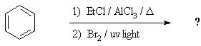

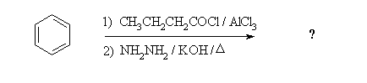

Q.15. What is the general mechanism of electrophilic addition reaction following Markovnikov rule?

Q.16.Write down the synthesis of commonly used drug molecule?

Q.17.What is peroxide effect? Explain it by giving suitable example and discuss its mechanism.

Q.18.Explain the mechanism of nucleophillic substitution reactions alonwith suitable example.

Q.19.Explain: SN1 lead to reemic misture ; whereas SN2 give rise to inverted product.

Q.20.What do you mean by cyclisation reaction .Exlain with suitable mechanism.

Q.21. Expalin: Rosenmund reaction and Saytzeff rule.